# CMSC 447

### Software Design and Development

# Fall 2022

# User Interface Design Document

Wordle Coach

User Interface Design Document

#### Table of Contents

Page

## 1. Introduction

* 1. Purpose of This Document 3
  2. References 3

2. User Interface Standards 4

3. User Interface Walkthrough 7

4. Data Validation 8

Appendix A **-** Agreement Between Customer and Contractor 10

Appendix B – Peer Review Sign-off 11

Appendix C – Document Contributions 12

## 

## Addendum 13

## 1. Introduction

Note: The design outlined in this document is a preliminary outline. An addendum has been added at the end of document detailing the differences in the actual user interface implementation.

1.1 Purpose of This Document

The purpose of this document is to provide a detailed description of the user interface of the Wordle Coach application. The intended audience of this document is a technical software developer, engaged in developing or updating the wordle app UI. This document will allow the development team to stay on track when programming the user interface. The user interface will be discussed in terms of standards, a walkthrough of the functionality, and the input and output data types of this interface will work with. There will be diagrams to go along with some of these descriptions to provide a more thorough understanding.

* 1. References

Wardle, Josh. "Wordle - A Daily Word Game." The New York Times - Breaking News, US News, World News and Videos, New York Times, 2022, www.nytimes.com/games/wordle/index.html. Accessed 20 Sept. 2022.

Team Odin. *Wordle Coach System Requirements Specification*. UMBC CMSC 447, 2022. Accessed 27 Nov. 2022.

Team Odin. *Wordle Coach System Design Specification*. UMBC CMSC 447, 2022. Accessed 27 Nov. 2022.

1. **User Interface Standards**

The layout of the Wordle Coach’s user interface will be like the Wordle game itself with some additional features and modifications. To keep this application as simple for the user as possible, it will only have one main screen or frame.

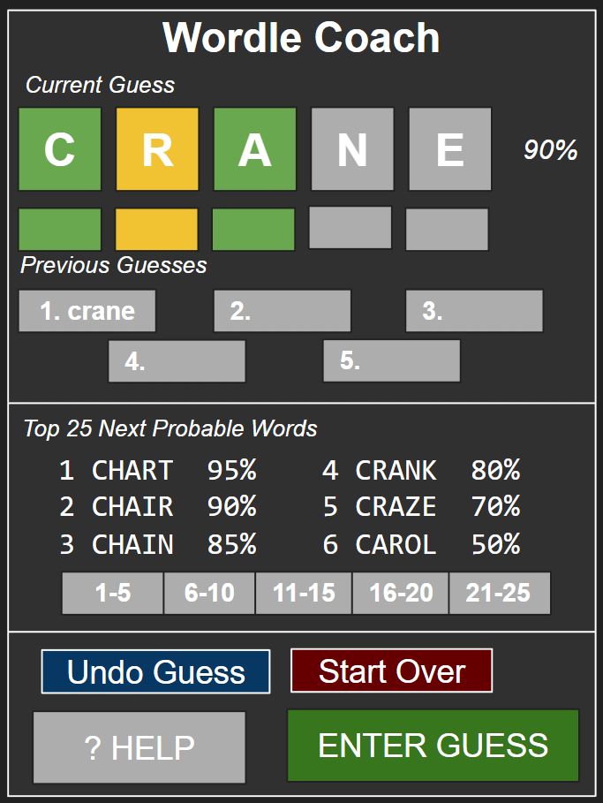

Figure 1: This is a sample mockup of how the main Wordle Coach frame will appear.

As shown in figure 1, there will be one main screen for the application which will display one row of the Wordle letter inputs. This will allow the user to type in each letter at a time and help to emulate a row in the actual Wordle game. Beneath this row, there will be blocks associated with each letter which will allow the user to select the color of that letter. The user will be able to tap on those associated blocks and cycle through the three colors. Upon being clicked, the block will change from gray to yellow to green and back to gray. Underneath this, there will be the top five previous Wordle guesses given the current guess input it filled out completely, meaning both the letters and block colors. On top of these top five guesses there will be a scroll box which will list twenty-five more most likely guesses. The user will be able to scroll up and down in this box in order to look at both the word and likelihood of that associated word.

For the user to submit their selection, there will be a large “Enter Guess” button on the bottom. When this button is pressed, valid user input will need to be checked. This means that all the user letters will need to be filled in with only a single letter. If this criterion is not met, the user will be shown an error and how to correct it. With the text input only allowing a single letter, the only error the user could get is to fill in the text.

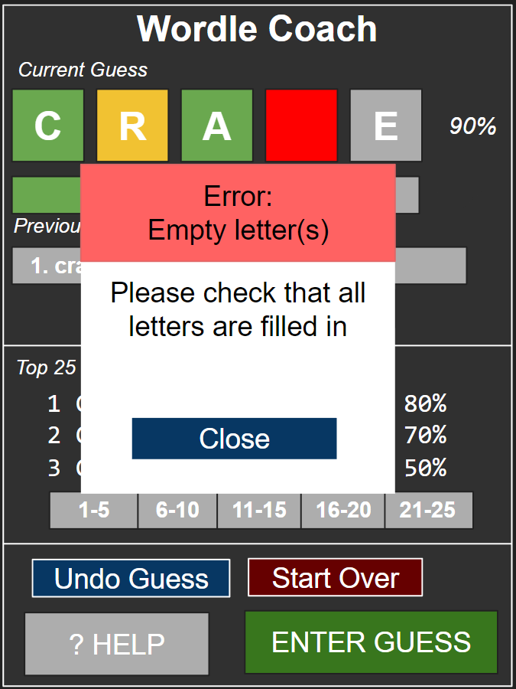

Figure 2: This is a mockup of the error that the user shall receive when not filling in all the Wordle blocks.

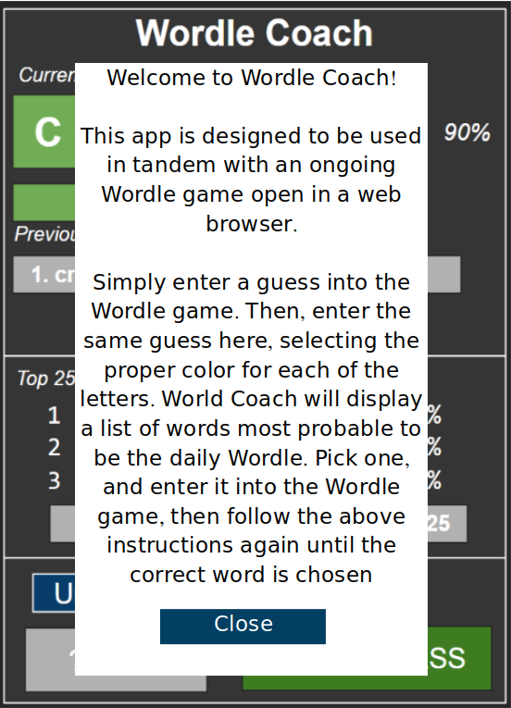

Figure 3: This is a mockup of the help screen that will be presented to the user when the “help” button is pressed

Figure 2 shown above, shows the screen the user shall receive when they enter a guess with one or more letters leaving empty. It will block the user from clicking anything on the screen except for the close button which makes the user acknowledge the error message. Furthermore, the block that the user left empty will temporarily turn red until the error message is closed. This will point out the block to the user in order to provide a more friendly user experience.

Continuing with functionality, there will be a “Start Over” button which the user can press in order to clear all data displayed or typed in. This means that all displayed predictions as well as the wordle board will be reset. This will reset the app to its start state. Near this button will be a “Help” button which will display instructions on how to use this application. The final button that the Wordle Coach application will display is the “Undo Guess” button. When the user presses this button, the previous prediction that the user pressed “Enter Guess” will be undone. This means that the combination of letters and associated colors the user enters will need to be stored. If the user were to press this “Undo Guess” button with no previous guess input, nothing will happen. There will need to be a condition to catch this from removing from empty storage which would result in an error in the application.

1. **User Interface Walkthrough**

Provide a diagram that illustrates how the user will navigate from one screen to another (I call this a “navigation diagram”). Label each symbol that represents a screen so that you can reference the screens, if necessary, later in the document. Give a brief description of what the diagram as a whole represents.

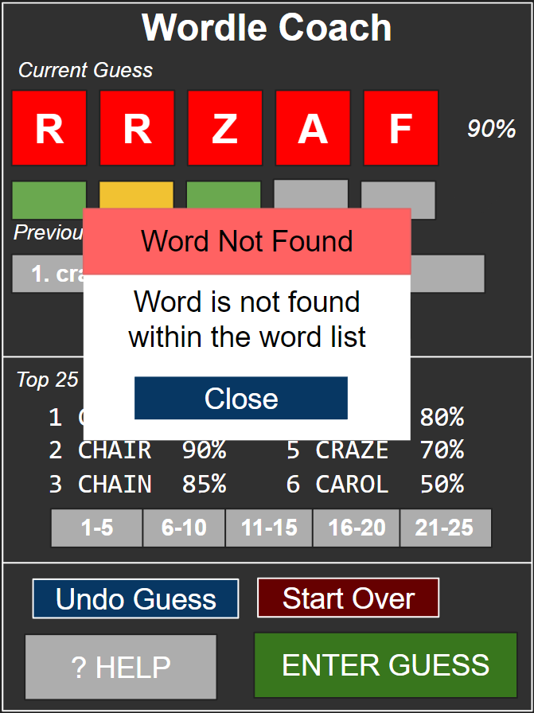

Figure 4: This image shows a mockup of the pop-up screen for when the word the user submitted is not found in the Wordle dictionary.

Next, guide the reader through a series of screen shots of all system screens. (You do not need to include error and confirmation messages/pop-ups.) Give the screen shots figure numbers and labels that match those in the navigation diagram. Refer to the figure numbers in the text of the walkthrough. Explain what the reader is seeing in each screen shot: the major screen areas, menus, what each button does, how to navigate to the next screen or return to the previous, etc. Note that if a feature has been standardized (e.g., how to return to the previous screen) and explained in Section 2, you do not need to repeat it here.

1. **Data Validation**

Data Validation Table

Note: For any UI elements not listed, data validation is not applicable

|  |  |  |  |
| --- | --- | --- | --- |
| Name of Input | Permitted Data Type | Limits | Description |
| Single letter for board | char | Only a single character | This is the letter the user can type in for each of the five Wordle board blocks |
| Color selection button | n/a | Allows a single tap to select | Button allows user to tap to change the color of the block |
| Enter Guess Button | n/a | Allows a single tap to select | Button confirms that the user has typed a letter in all 5 slots and that the letters spell a word in the Wordle word list. If so, it adds it to the list of guesses. |
| Undo guess button | n/a | Allows a single tap to select | Simply shows a pop up menu asking if the user is sure they want to undo, then after confirmation, it will undo |
| Start over button | n/a | Allows a single tap to select | Simply shows a pop-up menu asking if the user is sure they want to start over, then after confirmation, it will start over |
| Help Button | n/a | Allows a single tap to select | Opens a pop-up menu displaying a description of the app’s function and how to use the app |

**Appendix A – Agreement Between Customer and Contractor**

When the customer signs off on this page, they confirm that the UI design, and specifications of the UI outlined within the document are to their liking and fit the product's use case. Further, they agree to incur any additional costs associated with changing the UI after it has been completed.

When the dev team signs this document, they agree to develop a UI to the specifications contained herein, within the time allotted by the agreed upon development schedule. The dev team also agrees to develop a fully functional, and thoroughly tested UI, and agrees to not charge the customer additional fees for the remediation of bugs and errors.

**Appendix B – Team Review Sign-off**

This sign-off agreement confirms that all members of the Wordle Coach development team have both reviewed and agree with the provided content. Each member who has signed this has validated the user interface specifications and agrees that this work will be submitted as a team effort.

Signature: Date:

Zan Wills 10/25

Jamie Kirk 10/25

Dennis Mayher 10/20

Parth Patel 10/23

Nathan Hoernlein 10/20

**Appendix C – Document Contributions**

|  |  |
| --- | --- |
| Name | Role |
| Zan Wills | * Worked on appendixes A and B, user interface walkthrough |
| Dennis Mayher | * Worked on the introduction, user interface standards and user interface walkthrough |
| Nathan Hoernlein | * Worked on the data validation, document contributions, and user interface design |
| Parth Patel | * Worked on user interface design and user interface standards |
| Jamie Kirk | * Worked on the user interface standards section and data validation |

**Addendum**

Since the creation of this document, our UI design has changed a little after we finished developing the Wordle Coach app. Below are some screenshots of the actual UI from our application.

Our original UI design had buttons to navigate through each set of five guesses, however, we decided to implement scrolling functionality on the word list for a better user experience. Additionally, we removed the buttons underneath each letter to select the letter’s color, and instead the user now long presses on the letter box to change its color. We also no longer display a probability next to the entered guess, since it was unclear what that probability meant for the user. Finally, we changed the position of some of the buttons on the bottom, but they still have the same functionality as the original UI design.